Azure identity Access and security

Entra ID (azure AD)
- Is a directory that enables u to sign in and access both ms cloud applications and cloud applications that u develop.
- Ayure can also help u maintain ur on-premises active dir deployment.
- Use case: authentication, SSO, app management, device management
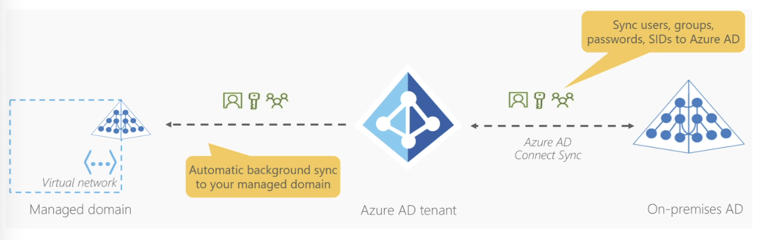

Azure active directory domain services (Azure AD DS)
- Service that provides managed domain services such as domain join, group policy, lightweight directory access protocol (LDAP), and Kerberos/NTLM authentication.
- Just like azure AD lets u use directory services without having to maintain the infrastructure supporting it, with this u get the benefit of domain services without the need to deploy, manage, and patch domain controllers (DCs) in the cloud.

Azure authentication methods
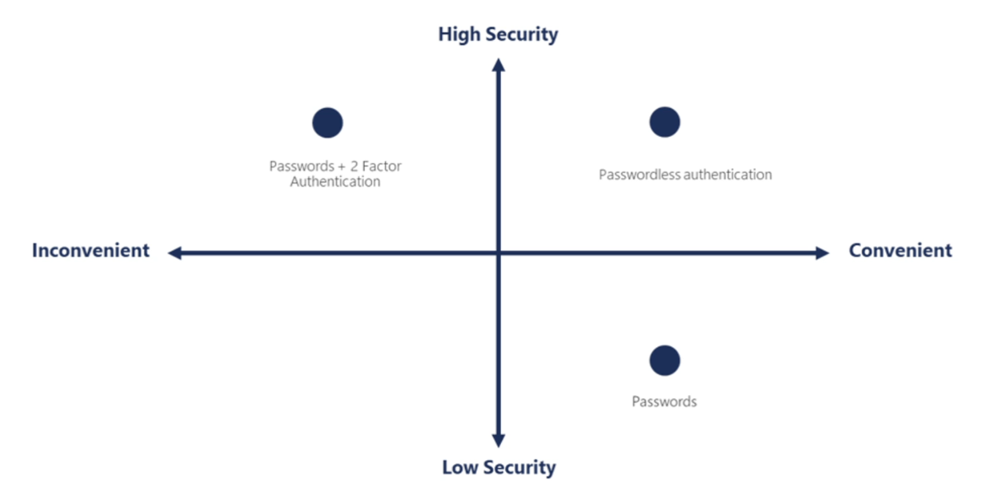
- Single sign-on (SSO)
- Multifactor authentication
- Passwordless authentification…

Azure external identities
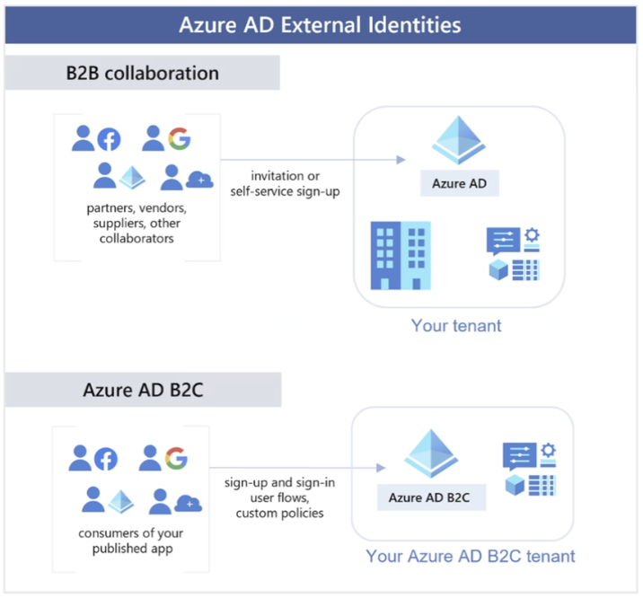

Azure conditional access
- It’s a tool that azure AD uses to allow (or deny) access to resources based on identity signals. These signals include who the iser is, where the user is, and what device the user is requesting access from.
- Conditional access helps IT administrators:
  - Empower users to be productive wherever and whenever
  - Protect the organizations assets
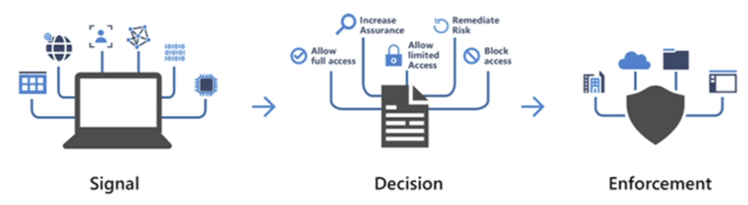
Basically adjusting the rights based on specific “signals”

Azure RBAC
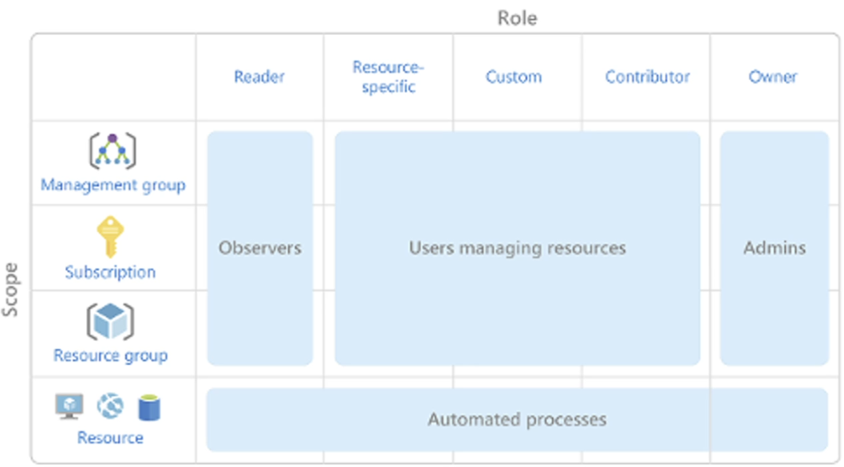

Azure zero trust
- Secure assets where they are with zero trust
- Classic approach
  - Restrict everything to a secure network
- Zero trust
  - …

Azure defense-in-depth
- Physical security layer is the first line of defense to protect computing hardware in the datacenter
- Identity and access layer controls access to infrastructure and change control
- Perimeter layer uses distributed denial of service protection to filter large scale attacks before they can cause a denial of service for users
- Network layer limits communication between resources throught segmentation and access controls
- Compute layer secures access to virtual machines….

Practical:
Network security tam sme vypli port na ssh pre jednu z dvoch VM-iek
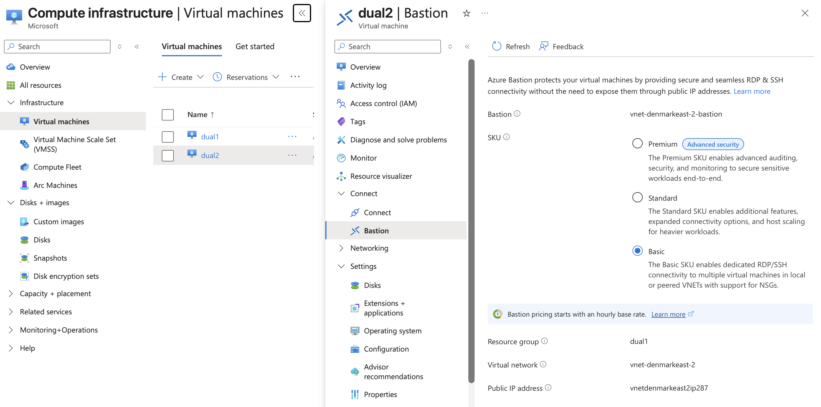
Idem nav m co nejde dam connect tam dam ze connect with bastion a vyberiem dev tu basic bo neni dev
Das robit bastion tak cakas ze 10m a boom toto
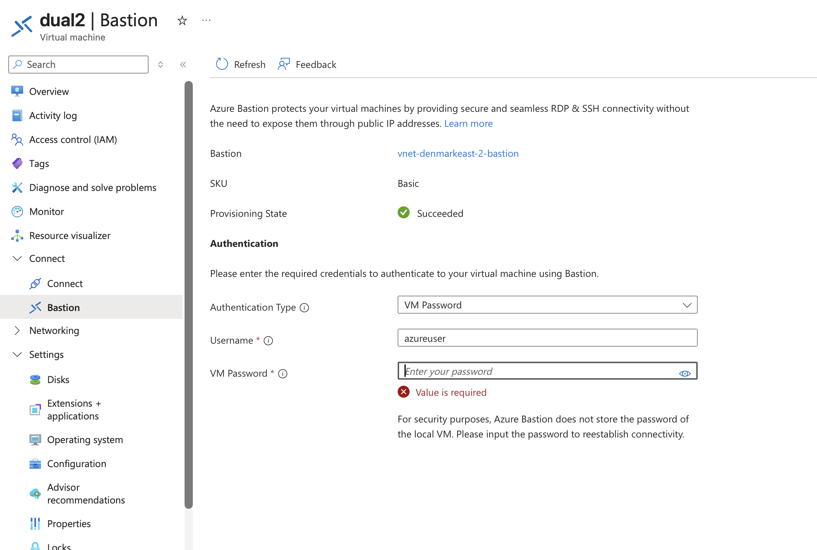

VNet peering tutorials
Open one of the VNets, for example vnet-denmarkeast-2.
Go to Settings → Peerings → + Add.

